Functional Specifications

- Add an additional button to invalidate the rows.
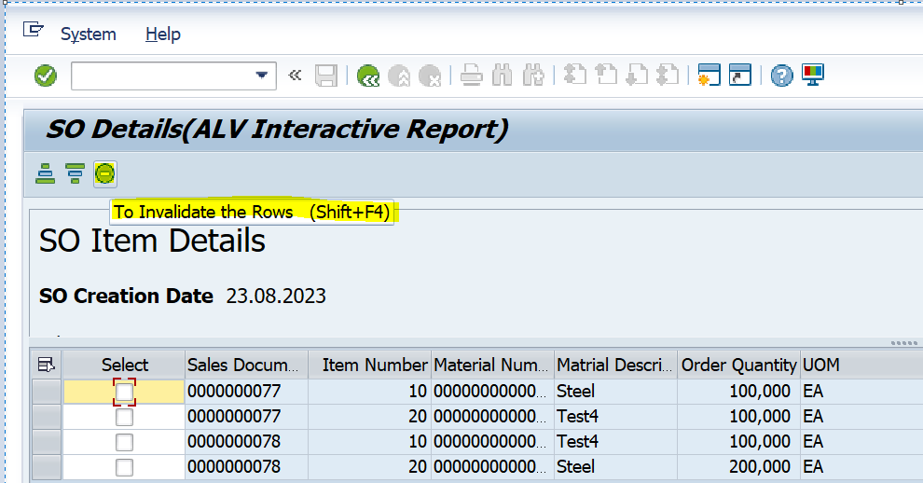

- Whenever, user will select the rows and click on to invalidate button, the invalidated rows should not appear in the report, smartforms and adobe forms.

- The invalidated rows must be stored in the custom table with date, time, and user.

Table structure/columns:
Sales document number
Line-item number
Date
Time
User

